How Does the Transit Bus Work?  There is no charge to use the Parsippany Transit System. The bus is available to ALL Parsippany residents.  Route 1 & Route 2 buses run Monday-Friday 9am-12pm &  1pm-4pm. They run on the hour starting at Morris Hills Shopping Center.  There is no bus service on holidays and weekends.  Shopping carts, carriages and strollers may be carried onto buses only when they are properly folded and do not obstruct entrances, exits or aisles. Shopping carts that do not fold-up are not allowed.  In all instances the operator of the bus may refuse boarding if the passenger load is such that boarding with this type of item will pose a safety hazard for our patrons.  Please call 973-263-7352 to confirm the buses are running.  All times shown on the schedule are approximate!  Rev. 4/26 |  | Passenger Rules  Please help us keep our buses as safe as possible for you and all of our passengers by following these rules at all times:  - No smoking, eating, drinking, littering, running, vandalism, graffiti, or hazardous materials.  - You must be able to ride the bus independently.  - No loud or intrusive use of profanity/ obscenities or other disorderly conduct, including threatening or harassing behavior to other passengers and/or driver.  - No inappropriate/distracting conversation with the driver.  - No fighting or conduct allowed that could pose a threat to public safety.  - No firearms or other weapons.  - Only service animals accompanying customers with disabilities or their trainers, police dogs, and small pets in carry-on  travel cages are allowed on-board.  - No solicitation for commercial or non-commercial purposes.  - Do not take up more than one seat or  place your feet on the seats.  - No electronic listening or music devices without headsets or earphones.  - Shirt and shoes are required.  - Follow all requests made by the driver.  - Report suspicious behavior to the driver. | Revised April 2026  Mayor Pulkit Desai  - Township of  - Parsippany-Troy Hills    - Free Transit System  - Bus Schedule  Please call to confirm the buses  are running.  973-263-7352  All times shown on the schedule  are approximate!

Route 1 Schedule  - Morris Hills Plaza :00  - Vail Manor :02  - Redstone Gardens :03  - Vail Rd. & Baldwin Rd. :04  - Dartmouth Village :05  - Baldwin Oaks :06  - Smithfield :07  - Target :11  - Rutgers Shopping Center :14  - WAWA :17*  - Shoprite Rt. 46 :19  - Vail Rd. & Greenbriar Rd. :22*  - Vail Rd. & Snoozin Tree Ln. :23*  - Vail Rd. & Pawnee Ave. :25*  - Lake Shore Drive & River :26*  - Lake Shore Drive & Wenonah :27*  - Lake Shore Drive & Beverwyck :28*  - Lake Shore Drive & Lincoln :29*  - Lake Shore Drive & Glenwood :30*  - Lake Shore Drive & Beachwood :30*  - Knoll & Lake Shore Drive :31*  - Knoll & Van Wyck :32*  - Senior Center/ Nutrition :33  - N. Beverwyck Rd. & Mara Rd. :34  - N. Beverwyck Rd. & Chesapeake :35  - N. Beverwyck Rd. & Minnehaha :36  - Foodtown - N. Beverwyck Rd. :39  - Eccola - Rt. 46 West :40  - Walgreens – Rt. 46 West :42  - Waterview Mrktpl. :44*  - Parsippany Post Office :45*  - Brookside :50  *By request only. Call 973-263-7352. | Parsippany-Troy Hills  Transit System  There is no charge to use the Parsippany Transit System  and the bus is available to ALL Parsippany Residents.  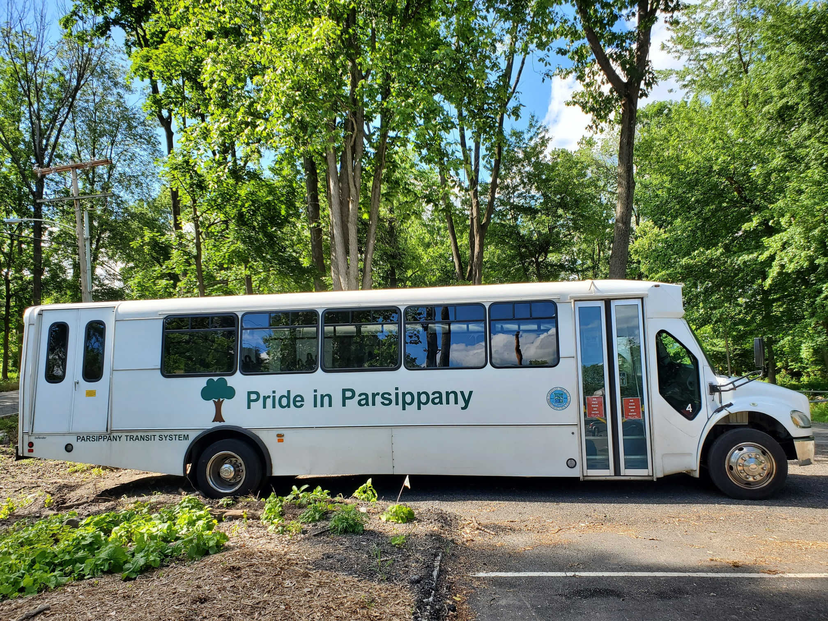  PICK UP FOR:  - VAIL MANOR AT BLDG. 2  PICK UP FOR:  - MTN. CLUB AT MAILBOX  How to Read the Bus Schedule: The “:xx” numbers to the right of each location indicate the minutes after each hour the bus arrives at that stop. Ex: Route 1 bus arrives at the Target stop (#8 on the list) at 9:11am, 10:11am, 11:11am, lunch break, 1:11pm, 2:11pm, 3:11pm.  The schedule repeats hourly starting at 9am. | Route 2 Schedule  - Morris Hills Plaza :00  - Brookside - 9:01 am and 1:01 pm only :01  - Tivoli Gardens (at NJ Transit bus stop) :01  - Cambridge Village/ Littleton Plaza :02  - Smith Road at Jillian Blvd. / The Shoppes :03  - Mazdabrook Rd. at Janelle Blvd :03  - Mazdabrook Rd. at Raymound Blvd. :04  - Mazda brook Rd at Care One :05  - Baldwin Road at PAL/VFW :05  - Rt 46 at Smith Field Park :06  - Target / Troy Hills Shopping Center :07  - So. Beverwyck Rd at Linda Street :08  - So. Beverwyck Rd at Beverwyck House :08  - Reynolds Ave at Hancock St. :09  - Reynolds Ave at Troy Hills Nurse Home :10  - Smith Rd. at Deauville Dr. :11  - Smith Rd. at St. Ann’s Church :12  - East Halsey Rd. at Smith Rd. :13  - East Halsey Rd. At Westminister Dr. :13  - East Halsey Rd. At Jefferson Rd. :14  - Board of Education :15  - Greenhill Plaza :16  - 300 Littleton Rd – corner Par Blvd + Littleton :17  - St. Christopher’s Church :20  - Rt 202 & Brooklawn Dr. :22  - Rt 202 & Dartford Rd. :23  - Rt 10 Barnes & Noble (am only) :26*  - Social Security :28*  - Powdermill Rd. & Rt 10W – 9:29,11:29 & :29  1:29 only  - Powdermill Rd. & Rt10E – 9:29,11:29 & :29  1:29 only  - Mountain Club -9:30,11:30,1:30 only :30  - Rt. 10/Kohl’s/Briarcliff Commons :35  - Rt. 10/Stop & Shop :36  - Halsey Rd. at Main Library :39  - Halsey Rd. & Teaneck :40  - Halsey Rd. & Ludlow Rd. :41  - Kingston Rd. & Madison Rd. :42  - Kingston Rd. at Hamburg :43  - Kingston Rd. at Boundbrook :43  - Marcella Rd. & Littleton Rd. :44  - CVS Rt. 46 :48  - Interval Gardens & Rt. 46 :50  - Waterview Mrktpl. (afternoon only) :51*  - Rt 46 at Parsippany Post Office :51*

